Cultural Properties Council Newsletter

April 2016

Council Chairman, Robert A. Carotenuto

I am proud to report the Cultural Properties Council continues the momentous work of my predecessors as Council Chair, Bill Powers and Gary Miville. Thanks to their leadership and guidance, I’ve been able to make a smooth transition into the role as Chair and champion goals such as recruiting ASIS International global members to our council and growing our membership. Indeed, new members Ibrahim Bulut of Belgium and Andy Davis of Great Britain have made an immediate impact, engaging in our historic and international committee meeting, held this past March, with Council CVP Leslie Cole, Council Vice Chair Gary Miville, Committee Chair Ricardo Sanz Marcos, and myself. We discussed how our council would answer the question, “How can ASIS International help our global members?’ Ibrahim will be writing an article on how security differs between the USA and Europe. Andy was instrumental in helping the council create our accepted 2016 Annual Seminar session presentation, “Soft Target Hardening Strategies,” and he will be joined by fellow council members Stevan Layne, Ronald Ronacher, James McGuffey and me. Andy will also be presenting an independent session at the Annual Seminar entitled, “Protecting Cultural and Hospitality Venues from Terrorist Attacks.” Terrific job by all those involved in developing two accepted sessions for this year’s ASIS International program in Orlando!

Cultural Properties Council
Members

Chairman
Robert A. Carotenuto, CPP
Vice-Chairman
Gary Miville
Darryl Marshall

Council Vice President
Leslie Cole, CPP
______________________
COMMITTEES (Chairman)

Museum Committee
Thomas Henkey
Library Committee
Bruce Segler
House of Worship
James R. McGuffey, CPP
Membership Committee
Eric Mallet
Newsletter Committee
Darryl Marshall
Mentoring Committee
Ray Van Hook, CPP
Women in Security
Monique Tarleton
International Committee
Ricardo Sanz Marcos
Aquarium/Zoo Committee
Gerardo Martinez

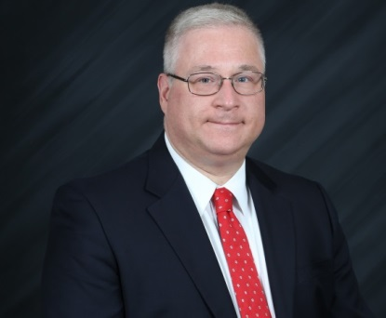
In February, I joined council members Ricardo Sanz Marcos and James Clark at the IFEMA, Feria de Madrid International Security, Safety and Fire Exhibition in speaking about security’s ROI with regards to cultural property security. Ricardo’s article will speak more about our visit. Ricardo and Rick St. Hilaire will be working on exploring the topic of archaeological site security, and both Security
Management Magazine and the ASIS International have shown interest in this work. We hope to speak to Dr. Arthur Kingsbury about the groundbreaking work that he and his wife have done in this area, much with the help of the ASIS International Foundation!

Cultural Properties
Council
Members

Guidelines Committee
Douglas A. Hall, PSP
Certification Liaison
R. Michael Kirchner, CPP
Young Professional Liaison
William J. Powers, III
_____________________
Council Members
Nick Artim
Douglas K. Beaver
Jeffery P. Berrett
Ibrahim Bulut
James H. Clark, CPP
Carl Chinn
Andy Davis
Eduardo De Diego, PSP
Warren P. Duane
Michael Gill
Ricardo Gomez
Donald Knox, CPP
Robert N. Layne
Stevan P. Layne, CPP
David Lesure
Bently Luneau
Nicki Luongo
Douglas M. Meacham
Johnnie Mock
Mark C. Peterson
Christopher Provan
Philip P. Purpura, CPP
Richard C. Raisler
Ron Ronacher, Jr., PSP
Rick St. Hilaire
James E. Stewart
Scott A. Watson, CPP

Council members have been very active, as this mere list of their accomplishments will testify:
- James McGuffey, published SRA program for distribution to ASIS International Council Chapters, and has already received great press for his work; webinar to follow.
- Jes Stewart is writing an article for Security Management Magazine on closing the culture/age gap in the workforce. He will also be speaking about customer service security at the Smithsonian National Council on Property Protection meeting this June.
- Ron Ronacher and Eduardo de Diego are drafting a white paper on Safety for Children in Museums and seeking to work with the School Safety Council on a document useful to both groups.
- Doug Hall will be leading the Smithsonian National Council on Cultural Property Protection June 1-3 in Washington, D.C.
- Tom Henkey, Museum Committee Chair, has organized ongoing committee meetings
- Michael Kirchner, who chairs the AAM Security Committee, has been instrumental in assisting several council members sharpen their presentations to acceptance and so Doug Hall, Mark Peterson, Bill Powers, Chris Provan, Steve Layne, Mike and I will all be speaking about cultural property protection and promoting ASIS International at the AAM Annual Meeting and Museum Expo in D.C. this Memorial Day weekend.
- Doug Beaver will be working with Rob Layne and Doug Hall on gathering survey data regarding the use of metal detectors at cultural property facilities.
- Darryl Marshall, Council Vice-Chair, has drafted our council brochure and continues as editor of our newsletter.
- Gary Miville, Council Vice-Chair, and I will be promoting our council at the ASIS NYC Chapter Security Conference and Expo April 27-28.
Lastly, our council continues to grow, and so I would be remiss if I did not welcome our other new council members: Douglas Beaver, National Museum of Women, Washington D.C.; Michael Gill, Fine Arts Museum San Francisco; Warren Duane, Philadelphia Museum; Nicki Luongo, MFA Boston; Bently Luneau, Fine Arts Museums San Francisco; and Christopher Provan, Colgate University. We look forward to their contributions to our council.

International Arts and Antiquities
Security Forum – (IAAS)
By Andy Davis

In November 2016 the first IAAS-Forum is being held in Newcastle Upon Tyne, in the North East of England. The purpose of the forum is to provide those with a responsibility for protecting Arts and Antiquities with a setting where they are able to learn about the risks that exist, how to successfully manage them and to understand the support services and latest technologies that are available to help them with this challenge. The event is being held at the Baltic Centre for Arts that has been a part of the Cultural regeneration experienced within this part of England.
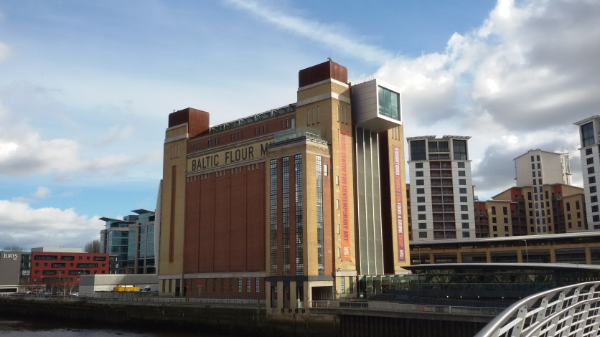
(Baltic Centre – Venue for IAAS-Forum 2016)
Background
After 14 years working overseas for the British government and corporate clients; including an involvement with museum designs, cultural events and international exhibitions I returned to the UK in order to spend more time with my family and establish my company in the UK. The summer of 2015 was brilliant, I was able to spend time visiting historical castles, museums and cultural events that I hadn’t visited for many years. The only difference was that my thoughts, whilst admiring the beautiful artifacts, would always drift towards the security applications that existed; or in many cases were non-existent. This was further confirmed whilst visiting clients who held large private collections at their homes but had minimal layers of security to protect them and gallery owners who didn’t understand why they were losing artifacts on a regular basis; but had no protective security measures.
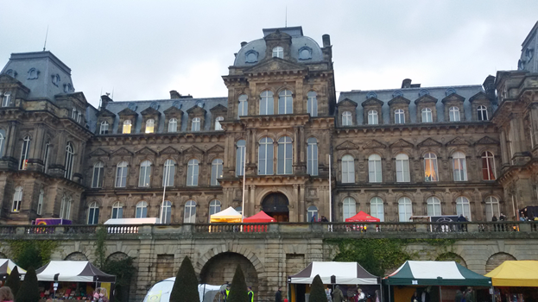
(Bowes Museum – Barnard Castle 1892)

For my clients I was able to support them and help reduce the risks they were exposed to. The larger museums and art houses are able to employ security professionals on a full or part time basis to support them. However, who was supporting the smaller museums, gallery owners and private individuals who do not understand the risks that exist or where to turn to for help and assistance? In many cases the wrong choices and unnecessary expenditure are made that do not always assist the clients or provide them with solutions.
It was through this lack of support and assistance that the original idea to host a UK based forum was created that would support and help them understand the risks that existed whilst increasing their ability to reduce the risks they faced, or where to go to for specialist support. Unfortunately, or in this particular case fortunately international colleagues started expressing an interest in attending and being a part of the event. It was at this stage that it became obvious that the interest was far greater than just within the UK and so it was agreed to make it an international event.

Since announcing the event a wide range of support has been received from those within the cultural community and the security industry, particularly from friends and colleagues who sit on the Cultural Property Council of ASIS International, but also from other professional security bodies within the UK.

Why is it Important?
The global cost of crime against arts, antiquities, cultural and heritage sites is estimated to be in the region of $10 billion annually, whilst in the UK alone it is believed to be in the region of $4-600 million; although there are no exact figures available. Part of the reason for not being able to identify an exact figure is through under reporting and actually being able to put an exact figure on a ‘priceless’ artifact. Although smuggling of arts and antiquities is believed to be third only behind drugs and weapons it in many cases is under-represented and falls under the radar of most people. This can be through it being seen as a victimless crime or where the victims are able to afford the loss, “they have insurance” is a quote I remember a seasoned criminal once telling me. A former colleague of mine has just completed the investigation into an organized crime groups theft of arts and artifacts valued at £60 ($100) million.

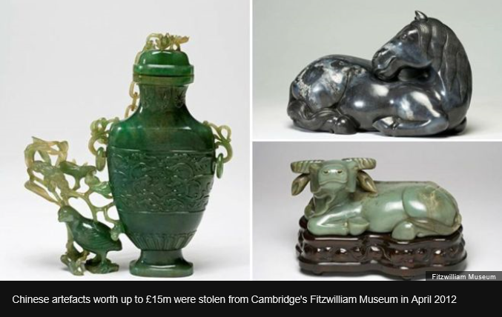
(From BBC News - http://www.bbc.co.uk/news/uk-england-cambridgeshire-35959089)

The fourteen offenders, many of whom had a long history of criminality received custodial sentences, the maximum of which was six and a half years. By any rational thought process if a robber had been caught with proceeds worth a similar amount the sentence would have been far greater. This level of punishment has to be seen as lenient; especially considering some of the artifacts have never been recovered.

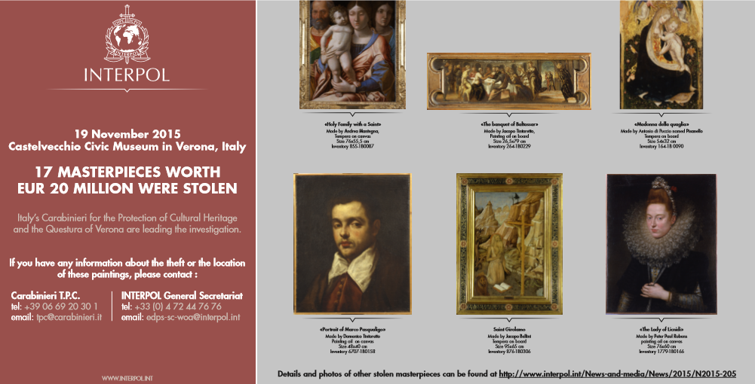
(INTERPOL – Stolen Art Poster- November 2015)

There are also financial and economic reasons why it is important to protect our arts and antiquities. The global cultural, arts and heritage industries employ tens of thousands of people directly and indirectly probably millions more. Imagine the impact on a small community if a museum or stately home was closed because they were unable to correctly protect their assets and it was no longer viable to remain open.

Finally it is important to protect works of art, cultural and heritage sites as they bring shared pleasure to millions of people. Wanton destruction like that witnessed in Palmyra Syria and earlier in Afghanistan where the Buddha’s of Bamiyan were destroyed by the Taliban prevents the world sharing the beauty that these items, along with others that have been stolen, destroyed or damaged.

Target Audience
It would be so easy to create an event that is directed at security professionals only but that is making some bold assumptions that all of the locations that need to protect their artworks and antiques have dedicated security personnel, they don’t. Therefore it was decided that anybody who is involved in the protection of arts and antiques whether they be security professional, curators, exhibitors, art movers or private individuals would be the audience that was aiming to be captured. It also included third party service providers such as investigators, art handlers, insurance companies and the providers of specialist technical support from security systems to laboratories.

Event Structure
It was important that the event programme was structured in such a way that it enabled the non-security professionals to understand and then benefit from the content. Therefore the event starts by identifying the true extent of the challenges that the arts, antiquities and cultural heritage sectors face on a daily basis. Case studies are presented and statistics provided that demonstrate the scale of the problem.

During the second part of the event programme it was important to identify subject matter experts from across the sectors to identify operational best practices and to share their experiences with the delegates.

The final stage of the programme is dedicated to those support sectors that are available to help reduce the risks faced by the sectors and includes the insurance sector, specialist logistics companies, investigators and research laboratories that provide confirmation services.

Running alongside the educational presentations it was important to identify and acknowledge the role played by technical security service providers and therefore the provision of an exhibition area dedicated to security and protective service providers has been established. All breaks and lunch are scheduled to take place within the exhibition area in order to ensure the maximum exposure for the exhibitors whilst enabling the delegates to spend sufficient time in order to understand what is available to help them reduce the risks they face.

Finally it was recognized that it was vitally important for the delegates to have time to be able to network. Enabling a small gallery owner to speak with a corporate head of security, for a private individual to understand how larger organizations protect their assets and for international experiences to be shared. To achieve this breaks have been scheduled throughout the day and an evening reception has been arranged overlooking the historical Quayside area of the River Tyne.

Future Intentions
Following on from this initial event the intention is to grow and develop it further with similar events taking place in Europe, the Middle East before expanding into China and the American markets.

Conclusion
The design and structuring of the Forum has taken over six months to complete and whilst there are commercial reasons behind it there is also a passionate desire to help and assist the industry to better understand the risks and protect the assets they have responsibility for. The Forum has been structured so that a continuous means of increasing awareness and vigilance is created, and can be spread but most importantly it is about helping preserve arts and antiquities for future generations.

Emergency Plans for Cultural Properties: An Introduction
By Tom Henkey

An Emergency Operations Plan (EOP) is designed to cover a wide range of events and incidents that may impact an organization. This strategic document is intended to provide an overview of the emergency plans and procedures for a specific cultural institution. It should be viewed as vital component of a larger and continuous process that includes threat assessment, preparedness, prevention, and mitigation. These steps are vital to inform and guide a successful organizational response and recovery in the event of a large-scale crisis or emergency.

The overall objective of an EOP is the protection of life, facilities, the collection, and the environment.
No plan can provide complete guidance for every potential hazard, yet a thorough EOP will build on realistic and current assessments to address the most likely risks from across a broad spectrum of natural, manmade, and technological causes. The document should be based upon best practices within the fields of cultural-property security and emergency management, and designed to comply with local, state, and federal guidance including the National Incident Management System (NIMS).

A standardized EOP format in NIMS consists of a core strategic document, augmented by several functional annexes addressing specific hazards and processes. Supporting documentation is also included for reference. (A table of contents at the conclusion of this article provides additional insight.)

The document identifies when and under what conditions the activation or initialization of the museum EOP is necessary. The range of hazards addressed shall include natural, human-caused, and technological threats, which have the potential for severe damage to property or the collection, or to cause multiple injuries or loss of life. The EOP should also serve as a guide to integrate external resources – local, state, federal, nongovernmental – in the event of a large-scale or escalating incident.

A complete EOP identifies the potential or likely hazards faced by the organization, and establishes a Concept of Operations for addressing incidents. It assigns specific functions to internal and external resources, and identifies key points of coordination and interaction among stakeholders.

It is also important to consult a wide range of professional or subject-matter experts. These could include: the American Alliance of Museums (AAM); the American Society for Industrial Security (ASIS); security managers at other local cultural properties; and the International Foundation for Cultural Property Protection (IFCPP).

Once completed and approved by senior staff, a single department should be responsible for ensuring that all changes to this document are distributed in an effective and timely manner. A Record of Changes Log should be included at the beginning of this document, and be actively updated to reflect any and all alterations to language or content. This process will help ensure that the plan is a “living document” and not another binder sitting on a shelf in the security office.

Sample Table of Contents for a Cultural Property EOP
I. Introduction  A. General  B. Purpose  C. Scope/Methodology  II. Situation  A. Hazard Analysis  B. Organizational Profile  C. Planning Assumptions  D. Disaster Classifications  III. Roles and Responsibilities  A. ABC Art Museum  B. Local Government  C. State Government  D. Federal Government  E. Non-Governmental and Volunteers  F. Professional Organizations  IV. Concept of Operations  A. General  i. Daily Operational Status  ii. Emergency Operations  iii. Response Coordination  B. Coordination and Control Authorities  i. ABC Art Museum  ii. City Government  iii. State Government  iv. Federal Government  v. Support Agencies  vi. Information Gathering and Analysis  vii. Communications/Notifications  C. Prevention Phase  D. Preparedness Phase  i. Plan Development/Maintenance/Revision  ii. Institutional Information  iii. Training and Exercises  E. Response Phase  i. Field Response Operations  ii. Emergency Operations Center (EOC)  iii. Incident Command System (ICS) | F. Recovery Phase  i. Field Recovery Operations  ii. Evacuation and Relocation  iii. Damage Assessment  iv. Governmental/Organizational Interaction  G. Mitigation Phase  V. Finance and Administration  A. Financial Management  B. Administrative Functions  VI. Continuity of Operations  A. Command Structure/Succession  B. Temporary Facilities  VII. Functional Annexes  A. Fire  B. Medical Emergency/Pandemic  C. Extreme Weather  D. Flooding  E. Earthquake/Structural Failure  F. Art Theft  G. Active Threat/Active Shooter  H. Bomb/Explosive Threat  I. Hazardous Materials  J. Civil Unrest  K. Cyber/Information Security  L. Evacuation  M. Shelter In Place  N. Search and Rescue  O. Mass Care/Shelter  P. Art In Danger  Q. Logistics Management  VIII. Appendices and References  - The National Incident Management  System  B. Emergency Operations Center Protocols  C. PASS Fire Extinguisher Guidance  D. Art In Danger Protocols and Temporary Storage  E. Memoranda of Understanding/Mutual Aid  F. Source Documents  G. Emergency Contact List

Does Your Security Plan Require a Facelift?
By Douglas K. Beaver, CPP
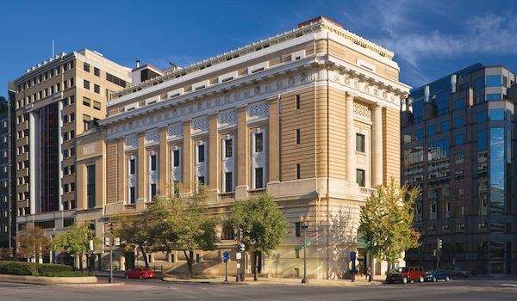
The National Museum of Women in the Arts (NMWA) occupies a historic building that was formerly the Masonic Temple of Washington, D.C. The building was originally constructed in 1908 and is listed on the National Register of Historic Places. The museum is a privately owned cultural institution and receives approximately 150,000 visitors annually.

The museum is located several blocks from the White House and adjacent to the Metro Center--the central hub station of the Washington Metro rapid transit system in Washington, D.C., which serves nearly 225 million riders annually.

Prior to my arrival, the museums security program had experienced a period of complacency, with slippage in many areas, leaving the collections in a relatively vulnerable position when considering the array of threats that loomed on the horizon. As in the sports world, many times a new coach is brought in to “right the ship” of a faltering team. In accepting the position as the museums Security Director, expectations were high and not dissimilar to the “new coach” analogy. To succeed, I felt that I had to design an environment that fully embraced the protection of our visitors, employees, collections, facilities, and intellectual property.

With a background rich in conducting risk assessments in high threat regions around the world, I endeavored to complete a comprehensive institutional vulnerability assessment to identify risks and ultimately develop effective countermeasures. The result revealed widespread vulnerabilities relating to the physical security program and access control systems. The systems in place were dated with an analog CCTV system as the lone core technological component.

The institutions “mature” access control system had gradually eroded to its present state of disrepair, while the physical security force had evolved to a disparate group of warm bodies occupying space. It didn’t take long to realize that there was much work to do. My first course of action was to develop a playbook with defined operational objectives and associated timelines.

I tackled the incongruous guard force initially by assessing their strengths and weaknesses. The results allowed me to identify inferior personnel who would be given the opportunity to either embrace the newly introduced standards, or be given the opportunity to move on. After developing a core set of operational guidelines and performance standards I held a series of team meetings to express expectations and subsequent ramifications for those who failed to meet those standards. With a policy of progressive discipline in place, the process took several months to complete. Documentation, counseling and disciplining of personnel who failed to meet these new standards of conduct resulted in the exodus of stale personnel, thus creating an

opportunity for the introduction of new team members. I was concurrently recruiting potential candidates to backfill the anticipated loss of personnel. With the new security team established, I felt that a major upgrade to the existing dismal uniform would elevate morale and encourage a more professional demeanor. As expected, the uniform change resulted in a significant attitude improvement and the security team, as a whole, felt better about themselves and the jobs that they were performing. They sensed that employees and visitors they interacted with on a daily basis treated them with a higher level of respect. I soon began receiving complimentary notes from visitors acknowledging the enhanced professionalism of our guard force. The morale improved dramatically as did the ongoing performance of the security team. With the subsequent development of a comprehensive SOP and a schedule of regular in-service training sessions, the staff maintained a positive attitude, which reflected favorably upon the entire security team and made for a vastly improved visitor experience.

With the overhaul of the physical security team complete, I turned my attention to the CCTV system. Upgrading does not necessarily require throwing out the proverbial ‘baby with the bathwater’. From past experience I knew that integrating old equipment into a new system could save both time and money and something as simple as adding the newer recording device can greatly enhance system-wide performance. I determined that our existing cameras, labyrinth of cabling and video recorder were all compatible so there wasn’t a need to alter any infrastructure. This was an important discovery due to the fact that the building was tagged as “historic”, a designation which brought with it limitations which could ultimately impact the costs and the extent to which infrastructure could be altered. I ultimately elected to go with a hybrid video recorder that allowed my existing cameras to stay put and I was able to effectively record their feeds while allowing for the installation and integration of newer IP based security cameras. The focus on being able to expand the existing network, before scrapping it, is the most cost effective route for anybody with an existing system. The most important aspect for the upgrades was having foresight into the current and future capabilities of the network. A little forethought in this regard can saves a lot of time and hassle in the end.

The final piece of the security “makeover” related to access control, which had been handled in the most basic of ways…a docent offering a pleasant greeting to museum visitors and patrons. Although the Security Operations Center (SOC) was adjacent to the docents’ octagonal desk in the museums rotunda, the SOC Desk Officer played a relatively insignificant role in the screening of visitors. This soft approach to access control is prominent amongst cultural institutions and spotlights the struggle security professionals face daily in trying to achieve fine balance between the need for open public access and their responsibility of implementing sound security practices. I believe that this “softer approach” had deteriorated throughout the years of complacency prior to my arrival, resulting in the current elevated level of risk.

In the cultural arts environment excessive security measures can undermine a positive visitor experience, but, at the same time, as cultural security professionals, we struggle to balance the desire for safe and secure institutions with the need for vibrant and connected public spaces.

As it turns out, the diluted screening protocol was one that was supported by the museum’s board of directors and consequently embraced by senior management. Although I viewed this as significant security vulnerability, I knew that the challenging political hurdle I faced would require the establishment of meaningful dialogue in order to be scaled.

With the support of our Facilities Manager, I successfully lobbied for the purchase and installation of a state of the art electronic access control system. In light of the ever changing security landscape, related to the alarming frequency of mass shootings, I petitioned the board of directors and museum management for consideration of the augmentation of our access control system with the introduction of walk through magnetometers. If implemented, this recommendation would satisfy my desire to deflect threats away from our institution. I felt the further hardening of our perimeter would indeed act as a tool to entice would-be terrorists to look elsewhere for “a path of least resistance”.

Museums, and related institutions, protect our cultural heritage. They provide for the long-term care and safety of our collective legacy while protecting employees, visitors, and facilities. With the increase in terrorist activities, mass shootings, natural disasters, and internal theft, many security professionals are left wondering---“What is the best course of action for ensuring the safety of our collections, the people, and the building?” While I don’t portend to have all of the answers, I feel that the steps we’ve taken have increased employee security awareness and created a safer and more secure environment in our institution.

The Security Risk Analysis Process For Houses of Worship
By Jim McGuffey

The Cultural Properties Council, House of Worship Committee has submitted a paper for Council review and consideration titled Security Risk Analysis (SRA) Process for Houses of Worship with the intent of sharing with all ASIS Chapters so they can administer to Houses of Worship in their communities.
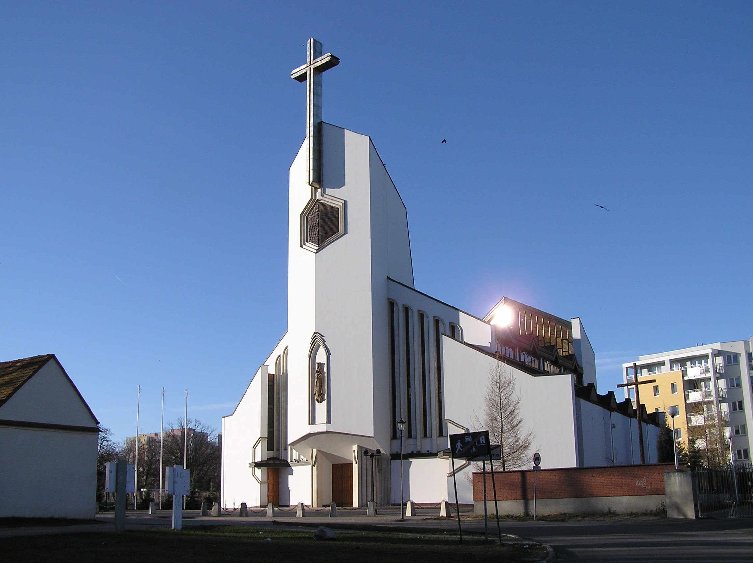

The SRA process teaches clergy how to identify and prioritize assets for protection as well as assess threats and hazards that could impact each asset. The level of impact and likelihood of occurrence is then assessed and appropriate security countermeasures assigned to mitigate risk. As part of the SRA, a security survey is conducted prior to the assessment to assist in identifying vulnerabilities in existing security countermeasures and operational functions.

This process was tested by HOW Chair Jim McGuffey, CPP®, PSP®, PCI® on December 16, 2015 when the ASIS Savannah Low Country Chapter #283 in partnership with the Bluffton, SC Police Department held a 3-hour seminar at the police department. During

this seminar, Jim presented the SRA process before 50 clergy, following the outline as presented by HOW Committee to Cultural Properties Counsel Chair, Robert Carotenuto. This event generated substantial publicity with both TV and Newspaper reporters covering the seminar.

Below are links regarding coverage for the ASIS Savannah Low Country Chapter SRA event:

http://www.wjcl.com/news/local-news/bluffton-pd-hosts-security-workshop-for-places-of-worship/111708440/story

http://www.islandpacket.com/opinion/opn-columns-blogs/liz-farrell/article50159730.html

http://www.wjcl.com/news/local-news/bluffton-pd-hosts-security-workshop-for-places-of-worship/111708440/story

http://wsav.com/2015/12/16/bluffton-pd-hosts-church-security-meeting/

http://www.wtoc.com/story/30769051/bluffton-police-holds-workshop-to-help-churches-deal-with-security-threats

Losing Control
By Mark C. Peterson
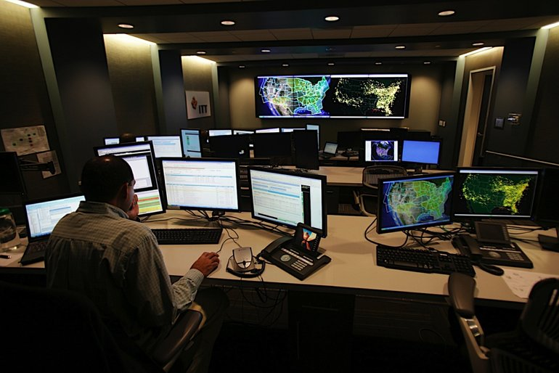
For security professionals, it is a familiar image. A diligent system operator sitting in a dimly lit space, surrounded by the glow of technology. The radio crackles as the operator communicates in 10-code with patrolling security officers in response to a security event. The quintessential security control center (SCC). Sometimes referred to as the security operations center, or simply the control room, it is the recognized heartbeat of many comprehensive security programs. By definition, this widely deployed security element is often the center of control for security operations.

Most commonly deployed within medium to large institutions, the SCC is often the element around which security operations revolve. The SCC may fill the command and control role within security operations. The definition of command and control in this application is to “provide direction of security resources for the protection of staff, visitors, and assets of the institution”. Operational direction by SCC operators should, or course, be given in accordance with the institution’s established policies and procedures. At a high level, SCC operators:
- Monitor electronic security systems to obtain situational awareness
- Communicate with security staff/patrols in response to security events
- Coordinate the assessment of, and response to, security events
- Document security activities

As electronic security systems (ESS) are deployed throughout the institution, the SCC has traditionally served as the centralized location for system monitoring and operation. This means that much of the investment in ESS can often be located within the SCC (Hey, we had to put that stuff somewhere). The expanded use of networked, or IP-based, systems has largely removed many of the constraints of older technology that made it difficult, and costly, to monitor and operate ESS across multiple locations. The traditional paradigm of centralized monitoring is now being challenged by today’s state-of-the-art system capabilities to more easily distribute system monitoring and operation across multiple locations.

With security operations, one size does not fit all. This also holds true with the role and operational expectation of the SCC. While they can be quite similar, each and every security organization is unique in its support of the institution’s unique environment and culture. So it is reasonable to assume that the role of the SCC can be different from institution to institution. How the role of the SCC may be different is less important than whether the role of the SCC is adequately defined. Only by defining the expectations of the SCC, within security operations, can its performance and effectiveness be properly evaluated. Regardless of the institution’s expectations of SCC operations, a few simple questions can help determine if the SCC is fulfilling operational expectations for predicable performance.

Is there a documented statement describing the role of the SCC?
The importance of documenting the role and operational expectations of the SCC cannot be overstated. SCC operations often occur behind the scenes. The organization, and executive management, does not always recognize the critical role that the SCC plays in securing the facility. As important, the organization does not always have an accurate expectation of SCC capabilities. Sometimes, inaccurate assumptions do not become apparent until a serious security incident is experienced. It is then that questions are asked like “Why wasn’t the incident identified on camera?” or “Why didn’t the operator alert security patrols in time to prevent the incident from happening?” Let’s face it; every SCC deployment has operational constraints and deficiencies. It is best to proactively understand and address these within the organization before they bubble up as the result of a serious security incident.

Do the SCC operator duties support the operational expectations of the SCC?
The role of the SCC operator is one of the most critical positions within the security organization. However, in so many cases, duties are assigned to SCC operators that are in direct conflict with their ability to monitor and respond to security events. SCC operators are often tasked with:

- Managing access control for contractors, visitors, and/or deliveries.
- Issuing visitor passes and temporary access badges.
- Issuing radios and other security equipment to officers.
- Issuing and managing staff keys.
- Answering the institute’s general phone line to answer questions and provide directions.
- Manage lost and found.

In many cases, these additional duties are assigned because the operational policies and procedures for SCC operators to actively communicate and engage with security officers and patrols are not adequately defined. From management’s point of view, SCC operators appear to have time on their hands, making them targets for other duties.

Are the SCC policies and procedures relevant to the current ESS configuration?
As previously discussed, state-of-the-art networked ESS provides security with enhanced operational features. If, and when, institutions are fortunate enough to be able to invest in system upgrades and/or replacement, the configuration of the SCC should change accordingly. It is not uncommon to see institutions spend significant capital dollars for the latest technology only to use them according to outdated policies and procedures. System upgrades and/or replacements are opportunities to reinvent security operations; increasing operational effectiveness and efficiencies.

Is the configuration of the SCC conducive to effective system monitoring and operation? The SCC environment must enable effective operator operations. In many cases the SCC is a 24/7/365 operation. The environment should support a comfortable and operationally efficient environment. Adequate temperature control and lighting are important for operator comfort. The layout of equipment is essential to effective SCC operations. The position of the operator in relation to user interface devices (monitors, keyboards, mouse, etc.) affects their ability to more easily manipulate systems. What is the expectation of operator performance in an environment where scores of video images are simultaneously

displayed? While it may look impressive, overloading the operator with video images may actually reduce their ability to identify activity of interest. The strategy for the configuration of video monitors must be in line with the performance expectations for the SCC operators.

Who has access to the SCC?
Due to the critical role of SCC, and the level of vigilance required for SCC operator duties, unnecessary distractions should be eliminated. That being said, there are many SCCs where security, and in some cases, non-security personnel freely enter the SCC. Even when fitted with access control, many of the institution’s staff have access privileges that include access into the SCC. SCC operations are very focused and time sensitive. Each and every access into the SCC creates the potential for distraction from identifying an important security events, or delay the assessment or response to an event. In most cases, the only persons that should be allowed to access the SCC are those security staff actively engaged in SCC operations, and their supervisors.

As I like to say, “It is always enough security until it isn’t”. It is difficult to quantify the effectiveness of security within an institution or to know just how many security incidents were prevented, or their impact minimized, as a result of security operations. The role of the SCC is not always apparent and, as a result, may fall victim to unnecessary distractions, overloading of duties, and inadequate policies and procedures. Ironically, when faced with a security event, the organization’s expectation for SCC operations is to spring into action, ninja style, to prevent or neutralize the security threat. While the critical role of the SCC is beyond dispute, it is not uncommon to find its effectiveness being undermined; even to the point of losing control.

Council of Cultural Properties – SICUR 2016
By Ricardo Sanz Marcos

Over the past 22, 23 and 24 February, on behalf of the Spanish Chapter of ASIS, I organized the visit to our country and further participation in SICUR'16 of our fellow Americans ASIS INTERNATIONAL, Robert Carotenuto (Head of Security Garden New York Botanical and Chairman of the Cultural Heritage ASIS) and Jim Clark (co- chair with me -together International Expansion Committee of the Council of Cultural Heritage ASIS).
On the 22nd, we were greeted by the Hon. Mayor of the Royal Site of San Ildefonso, Don Jose Luis Vazquez Fernandez, who made a statement of the importance of the concept of Cultural Heritage in your area, encompassing the directors axes that structure the territory depend Natural Resources (Biosphere Reserve and the Guadarrama National Park), Cultural Resources (Royal Palace of la Granja de San Ildefonso and Riofrio, City of Enlightenment, Royal glass Factory) and Resource Economics (Industry glass and wood with presence in the locality for over 275 years).
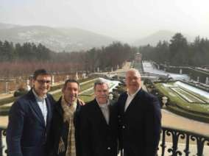
From left to right: Ricardo Sanz, Ignacio Vargas, Jim Clark and Robert Carotenuto, at the Royal Palace of La Granja.

The contribution of our Council of Cultural Heritage, addressed the importance of protecting and conserving the immense cultural heritage that holds the actual site, and where we could directly see proof of this through the Security Management held in the Royal Palace and Gardens, explanation given by its head of his Security D. Genaro Peinador.
Already in SICUR'16, after months of organization, we were able to provide the technical conference entitled "Security ROI: Example of Cultural Heritage"
The speakers:
- Robert A. Carotenuto, Chairman of the Committee for the Protection of Cultural Heritage of ASIS.
- James H. Clark, Member of the Committee for Protection of Cultural Heritage of ASIS.
- Sonsoles Navas Hernandez, Head of Museum Security, Office of State Museums, Ministry of Education, Culture and Sport.
- Ricardo Sanz Marcos, Managing Partner of PROARPA, Asset Protection and Heritage. Member of Committee for Protection of Cultural Heritage of ASIS.

Each of the speakers presented their own view on the matter to present and debate, highlighting the contributions ASIS has made through different papers on guidelines and best professional practices on security, with contributions from its partners around the world, Cultural Heritage sector. Attendees, around 50, discussed and enriched the day with many opinions and questions on the topics discussed.
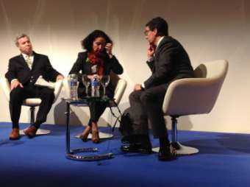
By order from left to right: Jim Clark, Sonsoles Navas and Ricardo Sanz.

The return on investment in security management is key in our profession. We are business managers in companies and institutions, where the business language, executive, is essential. Through security metrics, we are able to evaluate our work and to justify the budgets we have assigned to develop our share of the business and / or activity, part of the set of the overall objectives of the company or institution to which we belong.
I sincerely believe that also in the Protection of Cultural Heritage, ASIS International, leading solutions Security Management through the experience and professionalism of its thousands of partners around the world, and the tools available exclusively its members, through its website and working groups created in all sectors.
On the 35th anniversary of the Spanish Chapter of ASIS, professionals who make it up, continue to bring experience and knowledge to our international organization, leading from Spain, illustrating Security Projects and underlie the guidelines and best practices ASIS International.

Updates

2016 Smithsonian National Conference on Cultural Property Protection

The 2016 Smithsonian National Conference on Cultural Property Protection will feature two days of sessions, June 1 and 2, in Washington, DC at the National Museum of Natural History and the Newseum. More than 20 speakers will discuss topics ranging from public/visitor screening and the impacts of ISIS on cultural property, to cyber security. The keynote lecture will be on The Psychology of Democracy: The Real Danger of Terrorism.

June 3rd provides an opportunity for hands-on, interactive workshops (details forthcoming). As always, networking is emphasized throughout the day and at a special

evening reception offered this year at the Library of Congress. Registration, schedule, and other information can be found at natconf.si.edu.

International Foundation for Cultural Property Protection (IFCPP)
2016 Leadership Symposium
Aspen, CO
This year’s IFCPP conference boasts a host of new and exciting opportunities for cultural property protection managers. Scheduled for August 28-31, the 2016 IFCPP Leadership Symposium begins with IFCPP’s traditional Sunday evening welcome reception on the hillside rooftop of The Gant Hotel in downtown historic Aspen, CO, complete with a special presentation from the Aspen Historical Society! After guests gather from across the U.S. and abroad, we'll begin leadership workshops Monday morning in this iconic Rocky Mountain venue, just a few miles from the Continental Divide. Symposium participants will marvel at this beautiful and historically important setting.
The educational program will run 3 days, August 29-31, including leadership workshops, MOAB certification, the latest information on entry screening, a live exercise at a local museum, historic and cultural tours, networking activities, group meals, and much more! The conference ends the evening of August 31, with check-out on September 1st.
LODGING - The Gant Condotel offers 1, 2, and 3-bedroom mountainside condos. Conference participants can take advantage of shared 2 and 3-bedroom condo offerings at substantial cost savings - all condo options will be offered at more than 50% off of regular rates!!! We anticipate that guest will arrive a couple of days early to enjoy some free time, and bring along companions, spouses, and families.
THE PROGRAM - As the focal point of the event, IFCPP is very pleased to roll out this year's featured Symposium workshop series - Leadership: Great Leaders, Great Teams, Great ResultsTM. Do Security Managers as leaders know how to unleash the highest and best contribution of their teams toward their organization's most critical priorities? Today's leaders must be able to see their people as "whole people" - body, heart, mind, and spirit - and manage and lead accordingly. As a result, leaders spend their efforts creating a place where people want to stay and in which they are enabled to offer their best, time and time again.
More than just your average leadership training work session, Leadership: Great Leaders, Great Teams, Great ResultsTM helps leaders discover how to inspire trust and build credibility with their people, define a clear and compelling purpose, create and align systems of success, and unleash the talents and energy of a winning team. Leaders spend their efforts creating a place where people want to stay and contribute their best effort, time and time again, helping your organization achieve its most critical priorities. Presented by Steve Woolley, CIPM of 98-2 Enterprises, a “grass roots” leader with unique executive experience.
The Latest in Entry Screening: Procedures & Considerations. The Symposium’s second featured session. A common threat shared by all public institutions is the ease by which subversive, criminal, or terror-based offenders may bring destructive

items or weapons onto the property. Management has a clear duty to protect staff, visitors, and others from these threats, and provide a safe environment for work, study, or visitation. The best accepted method of doing so is through professional entry screening. Options include personal inspection, physical bag searches, magnetometers, and metal detection. Recent technology developments offer additional alternatives.
Any form of entry screening is labor intensive, and costly…the two prevalent reasons given for foregoing any form of scrutiny. The public expects and accept reasonable screening practices, now utilized in sporting event centers, most government buildings, theme parks, and a growing number of business centers. There are more considerations in addition to cost and staffing. This session will outline the pros and cons, and walk attendees through the necessary preparations for initiating reasonable entry screening, for a variety of environments. Presented by Stevan P. Layne, CPP, CIPM, CIPI

PRACTICAL EXERCISE - Security Self-Assessment: A Practical Exercise at the Aspen Art Museum. In conjunction with the Entry Screening session, the Aspen Art Museum will host Symposium participants for a special site security assessment exercise. Delegates will break out into teams to conduct a real-world assessment of this outstanding new museum. The assessment will include attendee evaluations of perimeter protection, physical security, systems & technology, staffing, patrolling, fire protection, protection of collections, policies & procedures, emergency planning, retail and food service considerations, a management Q&A, follow-up hot-wash, and prioritized recommendations.

Guaranteed to be a unique, fun, and rewarding experience for everyone involved! IFCPP is proud to invite our cultural property protection colleagues from around the globe. For additional information, please contact IFCPP or visit: http://ifcpp.org/2016-Symposium-Overview

